Fundraiser App Signup
Please follow the step by step instructions listed below to log in and create your account for your team fundraiser - 2021 Armstrong Volleyball

SIGN UP STEPS:
- Please go to www.afsports.biz
- Add to home screen
For Android
  - For Android click on the 3 dots on top of your browser
  - Scroll down and click “Add to Home Screen”
For Apple
- Open Safari and click the share icon at the bottom
- Click “Add to Home Screen”
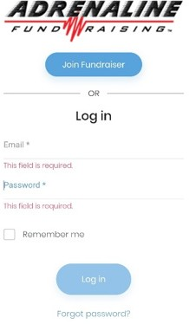
- Click on (DO NOT TRY SIGNING IN YET)
- Enter the code SYKGP9 (it is not case sensitive)
- Click
- Create an account. Please make sure you remember your password
- Pick your grade, team, and sizes

HOW TO ORDER:
- Click Place Order
- Pick the items the customer wants
- Enter customer details
- Select payment method (If check, enter check #)
  - NOTE: if customer is paying with Credit Card, for security reasons, order will need to be entered 2x (a link will be sent to the customer for them to enter order vs. the player).
- Select Paid
- Select Place Order

HOW TO SHARE:
- Click on “Copy” in your dashboard
- Paste this link into text messages, email, facebook, twitter, your IG home page or anywhere you can paste
- FOLLOW UP! Texting someone a link is the first step, NOT the last
- You get credit for anyone that clicks on that link and supports. This shows up in your orders.
- Deliver their product (Popcorn & Cookie orders – Player will deliver on/after Oct 11 | Sheets & Tumblers – will be direct shipped to customer)

Registration Process for Hibernate Bed Sheets
This product uses a separate site to order

Step #1 – Scan this QR Code with your phone | Step #2 –  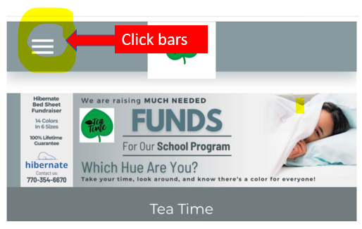
Step #3 –  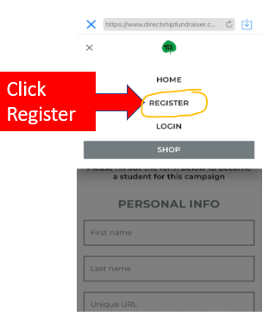 | Step #4 –  